**EXPERIMENT 5:**

**Demonstrate performing Regression on data sets**

**A]**

**Aim:** Load each dataset into Weka and build Linear Regression model. Study the clusters formed. Use Training set option. Interpret the regression model and derive patterns and conclusions from the regression results.

**Data set:**

@relation cpu

@attribute vendor{adviser,amdahl,apollo,basf,bti,burroughs,c.r.d,cdc,cambex,dec}

@attribute MYCT real

@attribute MMIN real

@attribute MMAX real

@attribute CACH real

@attribute CHMIN real

@attribute CHMAX real

@attribute class real

@data

adviser,125,256,6000,256,16,128,199

amdahl,29,8000,32000,32,8,32,253

amdahl,29,8000,16000,32,8,16,132

apollo,400,1000,3000,0,1,2,23

apollo,400,512,3500,4,1,6,24

basf,60,2000,8000,65,1,8,70

basf,50,4000,16000,65,1,8,117

bti,350,64,64,0,1,4,15

bti,200,512,16000,0,4,32,64

burroughs,167,524,2000,8,4,15,23

burroughs,143,512,5000,0,7,32,29

c.r.d,320,128,6000,0,1,12,28

c.r.d,320,512,2000,4,1,3,21

cdc,25,1310,2620,131,12,24,102

cdc,50,2620,10480,30,12,34,138

cambex,50,1000,4000,8,3,5,30

cambex,50,2000,16000,8,3,5,74

dec,133,1000,12000,9,3,12,54

dec,810,1000,5000,0,1,1,28

**Procedure:**

1. Load the dataset (Cpu.arff) into weka tool
2. Go to classify option & in left-hand navigation bar we can see different classification algorithms under functions section.
3. In which we selected Linear Regression algorithm & click on start option with use training set option.
4. Then we will get regression model & its result as shown below.
5. The patterns are visually mentioned below for regression model through visualize classifier errors option which is available in right click options.

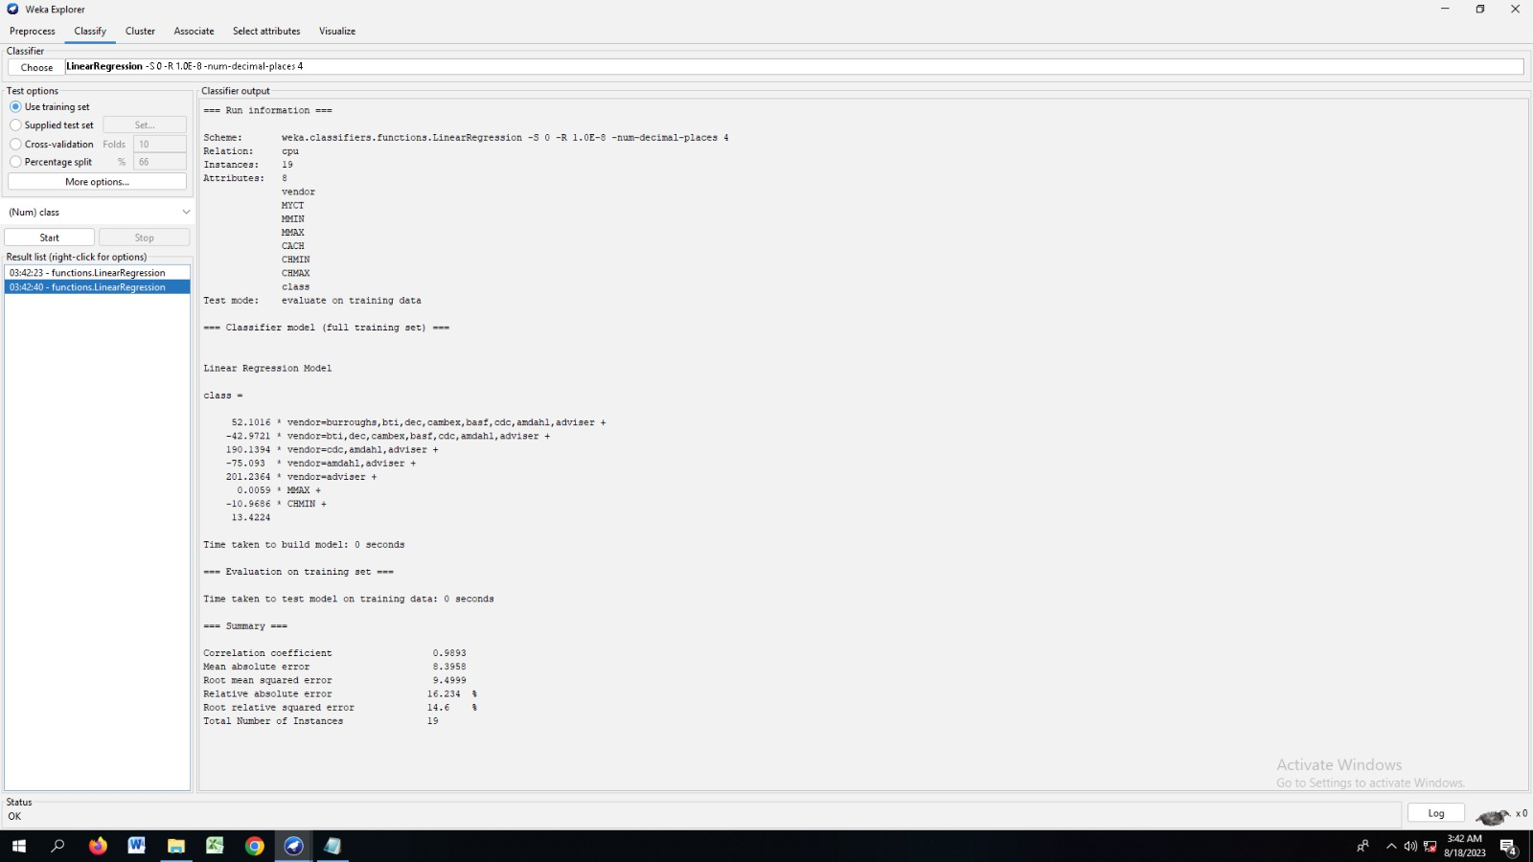

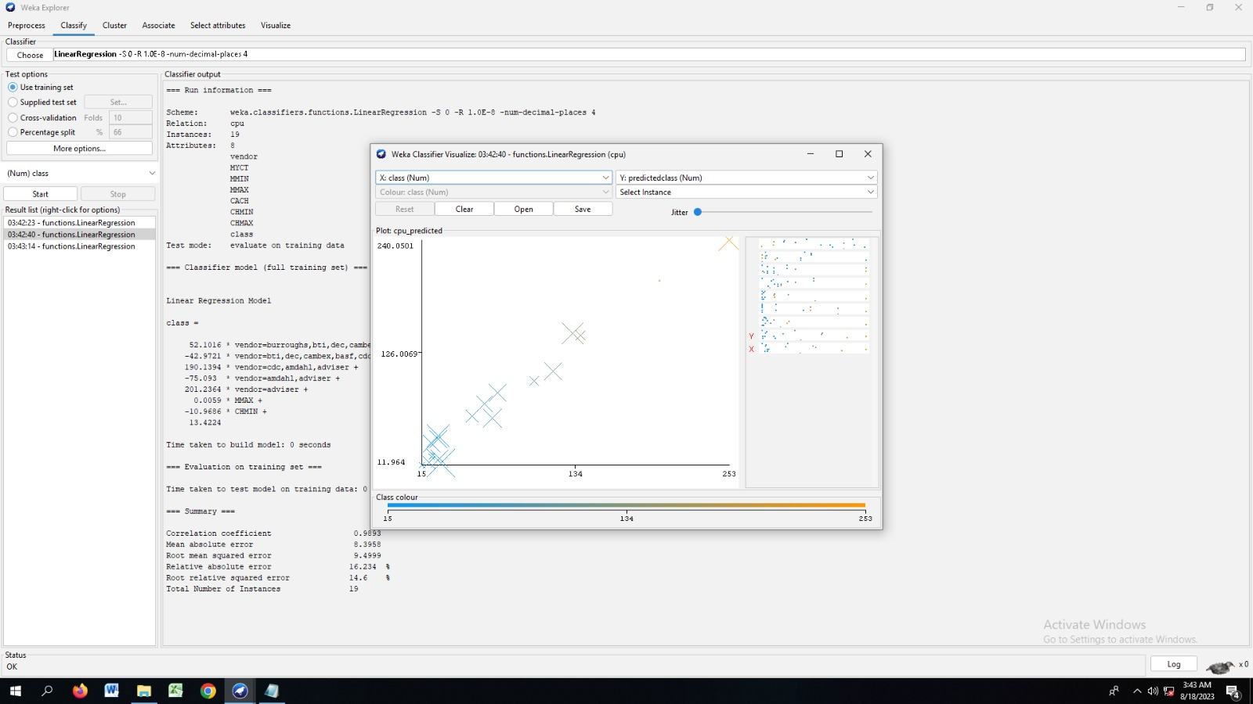

# B)

# Aim: Use options cross-validation and percentage split and repeat running the Linear Regression Model. Observe the results and derive meaningful results.

**Procedure for cross-validation:**

1. Load the dataset (Cpu.arff) into weka tool
2. Go to classify option & in left-hand navigation bar we can see different classification algorithms under functions section.
3. In which we selected Linear Regression algorithm & click on start option with cross validation option with 10 folds.
4. Then we will get regression model & its result as shown below.

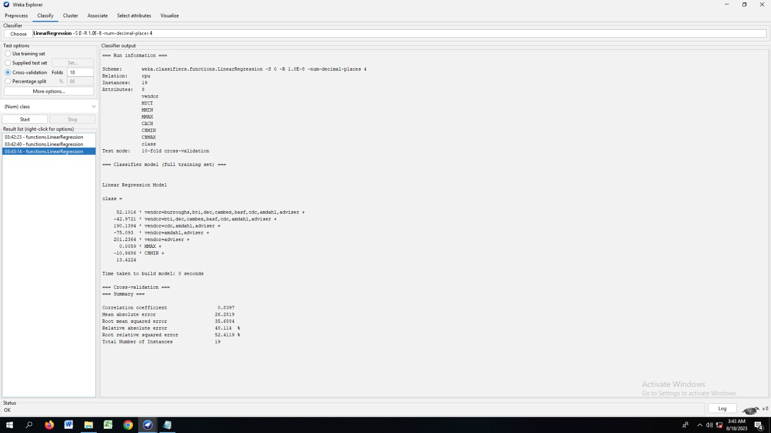

# Procedure for percentage split:

1. Load the dataset (Cpu.arff) into weka tool
2. Go to classify option & in left-hand navigation bar we can see different classification algorithms under functions section.
3. In which we selected Linear Regression algorithm & click on start option with percentage split option with 66% split.
4. Then we will get regression model & its result as shown below.

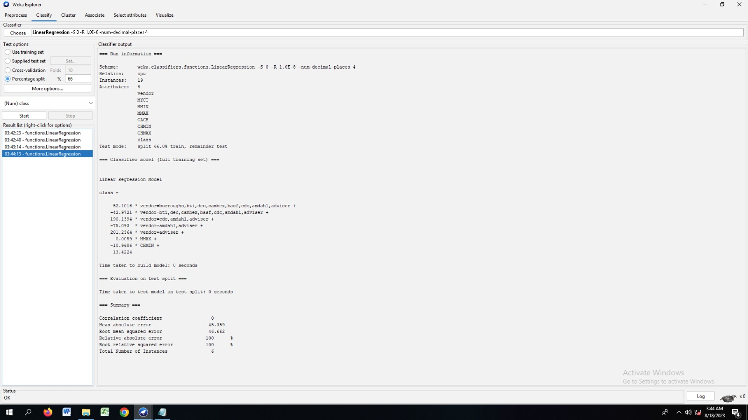

C)

# Aim: Explore linear regression technique that only looks at one variable

# Procedure:

* 1. Load the dataset (Cpu.arff) into weka tool
  2. Go to classify option & in left-hand navigation bar we can see different classification algorithms under functions section.
  3. In which we selected Linear Regression algorithm & click on start option with use training set option with one variable (MYCT).
  4. Then we will get regression model & its result as shown below.

